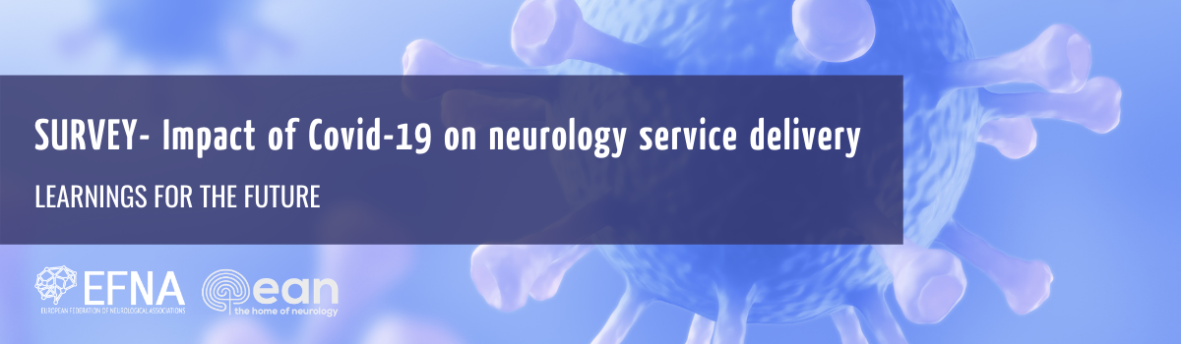
SURVEY – IMPACT OF COVID-19 ON NEUROLOGY SERVICE DELIVERY

A survey by the European Federation of Neurological Associations, in partnership with the European Academy of Neurology

PURPOSE OF THE SURVEY
Many surveys have captured the impact of the Covid-19 pandemic on patients’ access to treatment and care.
With this survey, we want to better understand how care pathways were reconfigured for the neurology patient community during the first wave of the pandemic. However, more importantly, we want to capture recommendations to ensure that any future changes to service delivery are made in the interests of the patients – rather than, solely, in the interests of the healthcare system.
Sharing your experience will allow us to better understand what worked well, but – also – where improvements need to be made. It will also allow us to understand what role patients themselves played in shaping the approach to their care during the pandemic.
This data will be used to inform the future advocacy of our neurology groups as we engage in the policy and decision-making that will inform the recovery planning.
It will also allow neurologists across Europe to understand the views of their patients to the approaches adopted during the pandemic, but also which learnings can be applied in the future delivery of care.

PARTICIPATION IN THE SURVEY
This survey is open to anyone who is living with a neurological disorder and resides in Europe.
The survey is completely anonymous and no personal information will be collected.
The survey should take less than 10 minutes to complete.
The data will be stored and analysed by EFNA, as per our data protection and privacy policies.
The results will be used to compile a short report and – possibly – a scientific publication to illustrate the impact of Covid-19 on neurology patients and the learnings for the future.
By completing and submitting this survey, as a participant, you are providing your informed consent. If you would like any additional information please do not hesitate to contact: communications@efna.net
The survey is open until November 20th 2020. It is available in 10 languages.
Thank you in advance for your participation, and please help us to disseminate this survey amongst your community.

Take the survey here (English language)
Or choose a language option below:
Note: the survey introduction is available in English only. Survey questions have been translated, however.
- Estonian – https://www.surveymonkey.com/r/33CCWY2?lang=et
- French (France) – https://www.surveymonkey.com/r/33CCWY2?lang=fr_FR
- German – https://www.surveymonkey.com/r/33CCWY2?lang=de
- Hungarian – https://www.surveymonkey.com/r/33CCWY2?lang=hu
- Italian – https://www.surveymonkey.com/r/33CCWY2?lang=it
- Portuguese – https://www.surveymonkey.com/r/33CCWY2?lang=pt
- Russian – https://www.surveymonkey.com/r/33CCWY2?lang=ru
- Slovenian – https://www.surveymonkey.com/r/33CCWY2?lang=sl
- Spanish – https://www.surveymonkey.com/r/33CCWY2?lang=es
- Turkish – https://www.surveymonkey.com/r/33CCWY2?lang=tr

